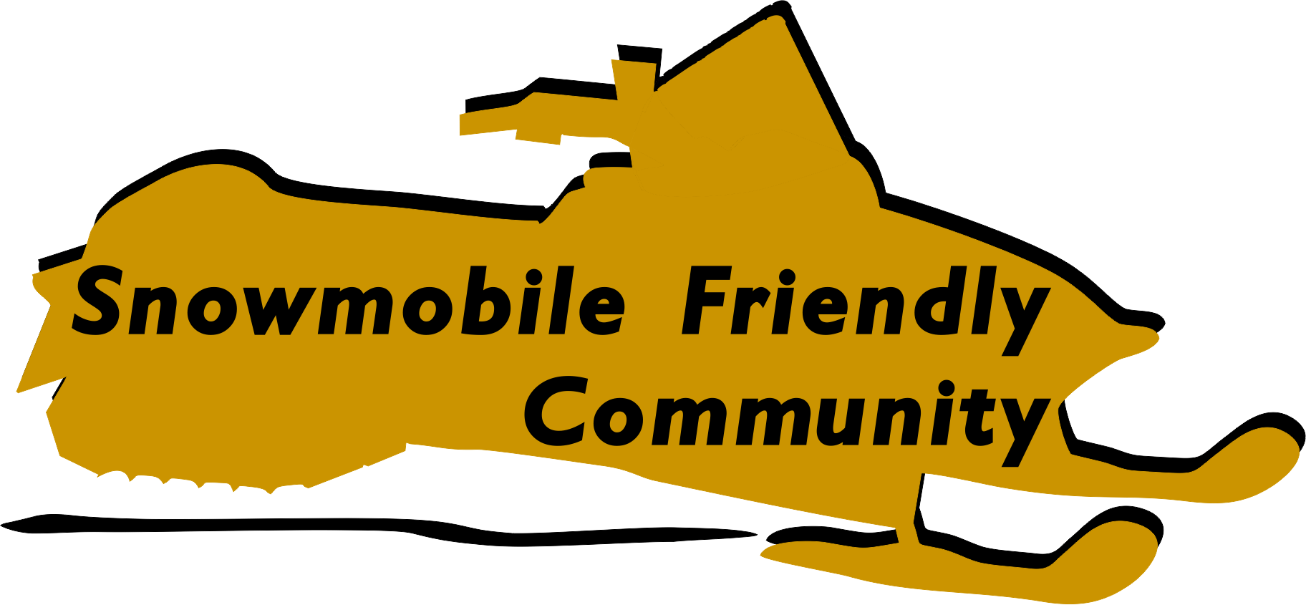

Program Guide:

Guidelines to
Enhance Snowmobile Tourism

American Council of Snowmobile Associations

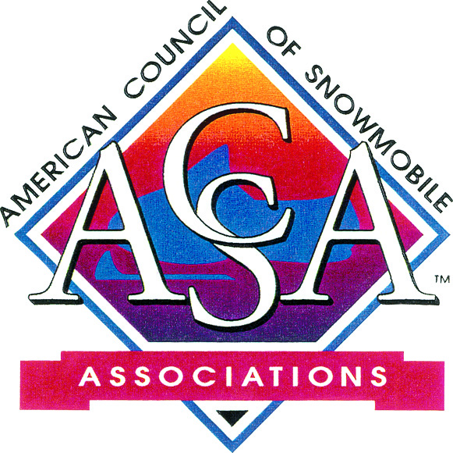

January 2015
Snowmobile Friendly Community Program Guide

Project Manager and Author: Kim Raap – Trails Work Consulting
3400 S. Florence Ave., Sioux Falls, SD 57103 (605) 371-9799 Trailswork@gmail.com

ACKNOWLEDGEMENTS AND DISCLAIMER

This program guide was developed by the American Council of Snowmobile Associations (ACSA) with funding provided by the Recreational Trails Program (RTP) administered by the U.S. Department of Transportation – Federal Highway Administration (FHWA).

ACSA’s leadership and members are recognized for their participation and guidance during project development. A special thank you to the International Snowmobile Tourism Council (ISTC) and its members for promoting the concept to enhance snowmobile safety, access, and tourism. It is also recognized that the concept for this program guide was spawned, in part, by The League of American Bicyclists’ much more elaborate Bicycle Friendly Community Program.

The sole purpose of this publication is educational only, with no other intent but to help expand the knowledge of local communities, businesses, clubs, associations, and trail managers. It should not be assumed that all contributors agree with every written word, but are opinions only. The authors, contributors, FHWA, Trails Work Consulting, ACSA and its members accept no liability resulting from the compliance or noncompliance with the findings or recommendations given herein, or for the accuracy or completeness of information contained herein.

Notice

This document is disseminated under the sponsorship of the U.S. Department of Transportation in the interest of information exchange. The U.S. Government assumes no liability for the use of information contained in this document.
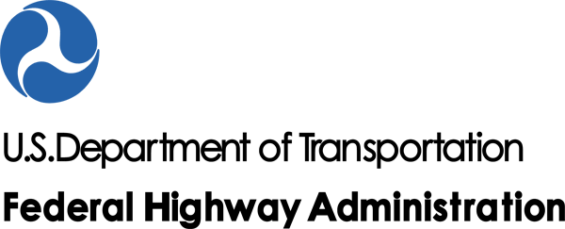
The U.S. Government does not endorse products or manufacturers. Trademarks or manufacturers' names appear in this report only because they are considered essential to the objective of this document.

The contents of this report reflect the views of the authors, who are responsible for the facts and accuracy of the data presented herein. The contents do not necessarily reflect the official policy of the U.S. Department of Transportation.

This report does not constitute a standard, specification, or regulation.

Provided by: American Council of Snowmobile Associations (ACSA)
271 Woodland Pass, Suite 216, East Lansing, MI 48823 (517) 351-4362
www.snowmobilers.org and www.snowmobileinfo.org

Copyright © 2015 Owned by the American Council of Snowmobile Associations
All Rights Reserved.
Information may be reproduced without permission by not-for-profit organizations and public agencies
for recreational trail safety, access education, or tourism promotion purposes.

TABLE OF CONTENTS

ACKNOWLEDGEMENTS AND DISCLAIMER . . . . . . . . . . . . . . . . . . . . . . . . . . . . . . . . . . . . . . 2

INTRODUCTION . . . . . . . . . . . . . . . . . . . . . . . . . . . . . . . . . . . . . . . . . . . . . . . . . . . . . . . . . . . . . . . 4

SNOWMOBILE FRIENDLY COMMUNITY . . . . . . . . . . . . . . . . . . . . . . . . . . . . . . . . . . . . . . . . . 4
What Helps Make A Community ‘Snowmobile Friendly’. . . . . . . . . . . . . . . . . . . . . . . . . . 4
Potential Community Benefits When Designated ‘Snowmobile Friendly’. . . . . . . . . . . . . . 5

DESIGNATION PROCESS . . . . . . . . . . . . . . . . . . . . . . . . . . . . . . . . . . . . . . . . . . . . . . . . . . . . . . . 5
The Snowmobile Friendly Community Designation Process . . . . . . . . . . . . . . . . . . . . . . . 5
1. Application Deadline . . . . . . . . . . . . . . . . . . . . . . . . . . . . . . . . . . . . . . . . . . . . . 5
2. Guidelines . . . . . . . . . . . . . . . . . . . . . . . . . . . . . . . . . . . . . . . . . . . . . . . . . . . . . . 5
Club Criteria . . . . . . . . . . . . . . . . . . . . . . . . . . . . . . . . . . . . . . . . . . . . . . . . 5
Community Criteria . . . . . . . . . . . . . . . . . . . . . . . . . . . . . . . . . . . . . . . . . . 5
Area Business Criteria . . . . . . . . . . . . . . . . . . . . . . . . . . . . . . . . . . . . . . . . 6
Law Enforcement Criteria . . . . . . . . . . . . . . . . . . . . . . . . . . . . . . . . . . . . . 6
3. Designation Decisions . . . . . . . . . . . . . . . . . . . . . . . . . . . . . . . . . . . . . . . . . . . 6
4. Memorandum of Understanding (MOU) . . . . . . . . . . . . . . . . . . . . . . . . . . . . . . 6
5. Length of SFC Designation . . . . . . . . . . . . . . . . . . . . . . . . . . . . . . . . . . . . . . . . .6
6. Termination Clause . . . . . . . . . . . . . . . . . . . . . . . . . . . . . . . . . . . . . . . . . . . . . . 6
7. SFC Logos . . . . . . . . . . . . . . . . . . . . . . . . . . . . . . . . . . . . . . . . . . . . . . . . . . . . . 6
8. SFC Road and Trail Signs . . . . . . . . . . . . . . . . . . . . . . . . . . . . . . . . . . . . . . . . . 6

APPLICATION . . . . . . . . . . . . . . . . . . . . . . . . . . . . . . . . . . . . . . . . . . . . . . . . . . . . . . . . . . . . . . . . 8

COMMUNITY CERTIFICATION CRITERIA AND SCORESHEET . . . . . . . . . . . . . . . . . . . . . . 10

Example SFC MEMORANDUM OF UNDERSTANDING. . . . . . . . . . . . . . . . . . . . . . . . . . . . . . . 11

INTRODUCTION

Snowmobiling generates $22 billion in annual spending across the United States while also generating millions of dollars in tax revenues for state and local governments. It is extremely important to many local communities where it helps improve the quality of life during winter and brings tourism business in what otherwise would be an off-season for many areas. Snowmobile tourism can be particularly important in rural communities where it often helps businesses stay open and people employed year-round.

The Snowmobile Friendly Community (SFC) Program is provided by the American Council of Snowmobile Associations (ACSA) to help state snowmobile associations recognize communities and businesses that cater to the needs of snowmobilers. Communities and businesses designated as ‘snowmobile-friendly’ can benefit from enhanced tourism promotion opportunities. In turn snowmobilers benefit from improved safety and access to services, along with easy recognition of communities and businesses that will cater to their trip needs.

SNOWMOBILE FRIENDLY COMMUNITY

What Helps Make A Community ‘Snowmobile Friendly’?

Snowmobile Friendly Community offers some or many of the following elements to ensure sufficient snowmobile safety and access value is received to match SFC designation status:

- Community is directly connected to a system of groomed snowmobile trails and has at least one groomed snowmobile trail that runs through or directly adjacent to the community (suggested that this be mandatory for SFC participation)
- Community provides connections to services (fuel, food, lodging, repairs, etc.) within the community that can be accessed by snowmobile through any or all of the following methods:
- allows snowmobile operation on designated routes (trail and/or non-trail) within the community
- allows snowmobile operation on designated snow covered roadways
- allows snowmobile operation within road right-of-ways
- allows snowmobile operation on the shoulder of plowed roadways to cross bridges
- allows snowmobile operation on plowed road shoulders or at the outside edge of plowed streets or roads in order to reach businesses and/or residences
- Community has ‘snowmobile friendly’ snow removal policies that help prevent:
- creating safety hazards caused by snow removal operations unnecessarily depositing snow onto groomed snowmobile trails
- unnecessarily removing all snow cover from designated connecting routes (streets and road shoulders) needed for snowmobile access to key fuel, lodging and food services
- Community provides trail maps, signing and/or literature that clearly identifies designated snowmobile travel routes, along with any other materials which assist snowmobilers with trip planning
- Community actively promotes snowmobile tourism and snowmobile-related businesses
- Community educates area businesses about how to cater to the needs of snowmobilers
- Community educates snowmobilers and motorists about proper rules and etiquette for road sharing and road crossings
- Community regularly partners with local snowmobile club to promote:
- snowmobile safety
- equitable law enforcement related to snowmobiling
- coordination of emergency response efforts

Potential Community Benefits When Designated ‘Snowmobile-Friendly’

There are many potential incentives for local communities to participate in the Snowmobile Friendly Community Program. While every community’s circumstances will be different, potential benefits from SFC designation could include:

- New opportunities to market their SFC status on ACSA’s website, the Minnesota United Snowmobilers Association’s website, and the local snowmobile club’s website (if the club has one).
- Enhanced opportunities to tap into the local snowmobile club and Minnesota United Snowmobilers Association’s networks for snowmobile tourism marketing and community promotion.
- Heightened awareness to snowmobilers that the community is a worthy snowmobiling destination that is accommodating to their needs.
- More business and local tax revenues generated within the community from increased snowmobile tourism.
- Heightened awareness to snowmobilers that the community’s snowmobile friendly policies make it a safer snowmobiling destination.
- Improved safety margins for snowmobilers and the community’s motorists.
- Enhanced winter recreation opportunities for the community’s residents and visitors.
- Enhanced partnerships with the community’s local snowmobile club for emergency response efforts.

DESIGNATION PROCESS

The Snowmobile Friendly Community Designation Process

In order for a city, town, or area community to be deemed “snowmobile friendly” it will have created a partnership between the snowmobile club, community, businesses and law enforcement and must meet a criteria set forth by the Minnesota United Snowmobilers Association (MnUSA).

- Application Deadline: Application will be accepted by Minnesota United Snowmobilers Association by mail:
Minnesota United Snowmobilers Association
7040 Lakeland Ave., N. #212
Brooklyn Park, MN 55428

by email: nancy@popp.net

Application deadline is October 1st of each year to be considered for the upcoming season.

- Guidelines: The following guidelines must be met for any community before it receives MnUSA’s Snowmobile Friendly Community designation:

Club Criteria
Is the club a 100% MnUSA member club?
Is the club a member of the chamber of commerce and/or convention and visitor’s bureau?
Does the club promote safety and provide snowmobile safety training for youth?

Community Criteria
Does the community have a comprehensive, connected and well-maintained snowmobile trail
network?
Does the community have up-to-date maps and community information readily available to snowmobilers?
Does the community celebrate snowmobiling with community recognition of snowmobiling and
media outreach to the snowmobiling community?
Does the community actively pursue making sure that city trails have adequate snow cover by not
plowing trail routes?
Does the community host any major community snowmobiling events, shows or rides?
Does the community actively pursue the promotion of snowmobile tourism?
Do community officials meet regularly with the local snowmobile club?
Does your community promote businesses with the community that are snowmobiling specific?

Area Business Criteria
Is access to the community’s business district and/or services readily available to snowmobilers?
Do the businesses have an adequate number of services that cater to snowmobilers?
Do the businesses know the snowmobile trail system to provide information to travelers?

Law Enforcement Criteria
Are there community-wide ordinances or other policies that allow the accommodation of
snowmobiles?
Do law enforcement officers receive training on the rights and responsibilities of snowmobilers in
the community?
Does the community or other law enforcement providers have law enforcement officers on
snowmobiles?
Do local ordinances treat snowmobilers equitably in regards to other trail users?
Does law enforcement meet with local clubs to discuss enforcement issues?

- Designation Decisions: The Executive Board of MnUSA, or its designee(s)s, will review each application and determine the approval of the application.

- Memorandum of Understanding (MOU): There must be a written agreement signed by the community or business, sponsoring local snowmobile club, and MnUSA. This can be the MOU included in this document or another type of written agreement outlining the roles and responsibilities of each party based upon local preference.

- Length of SFC designation: The SFC designation expires five (5) years from the date of approval by MnUSA unless extended by an executed modification signed and dated by all parties.

- Termination Clause: Any of the parties, may terminate the SFC designation by notification in writing to all parties at the addresses on the MOU or written agreement.

- SFC Logos: Snowmobile Friendly Communities and businesses will be provided with a logo for use on advertisements, brochures, publications, etc.

- SFC Road and Trail Signs: SFC signs for posting either along entrance roads to the community and/or along snowmobile trails where they enter the community will be provided at a nominal charge.

All signs posted along roadways must be coordinated and approved by the state department of transportation (state or federal highways) or the local road manager. All signs posted along trails require coordination and approval by the landowner or trail manager. Signs will be a minimum 18” high by 24” wide.

Examples of the roadside and trailside SFC signs are shown below. The ‘white letters and black symbol on a forest green background’ conforms to the Manual for Uniform Traffic Controls Devices (MUTCD) for recreation signs. Additionally the green color is consistent with MUTCD guidance for ‘permissive’ activities. An extra tag line advising motorists to ‘Watch for Riders’ has been added to the roadside sign while an extra tag line advising snowmobilers to ‘Ride Responsibly’ in the community has been added to the trailside sign.

Roadside Sign
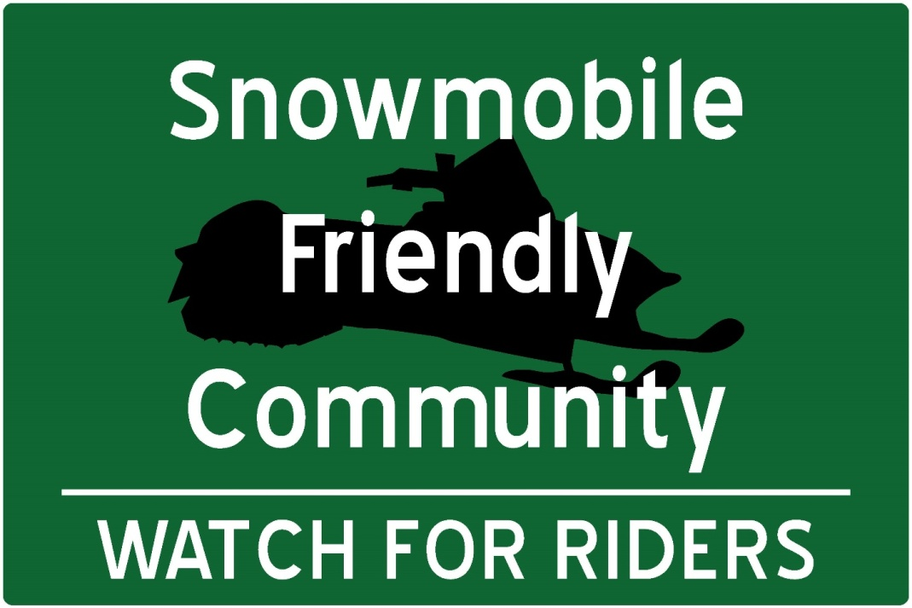

Trailside Sign
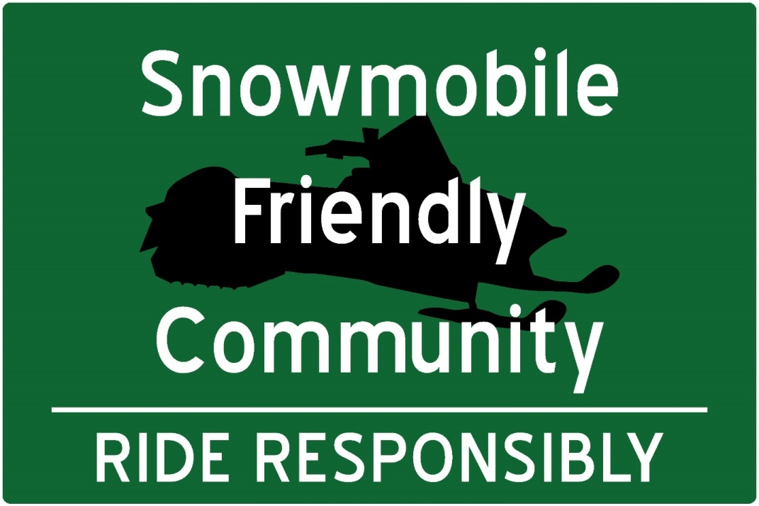
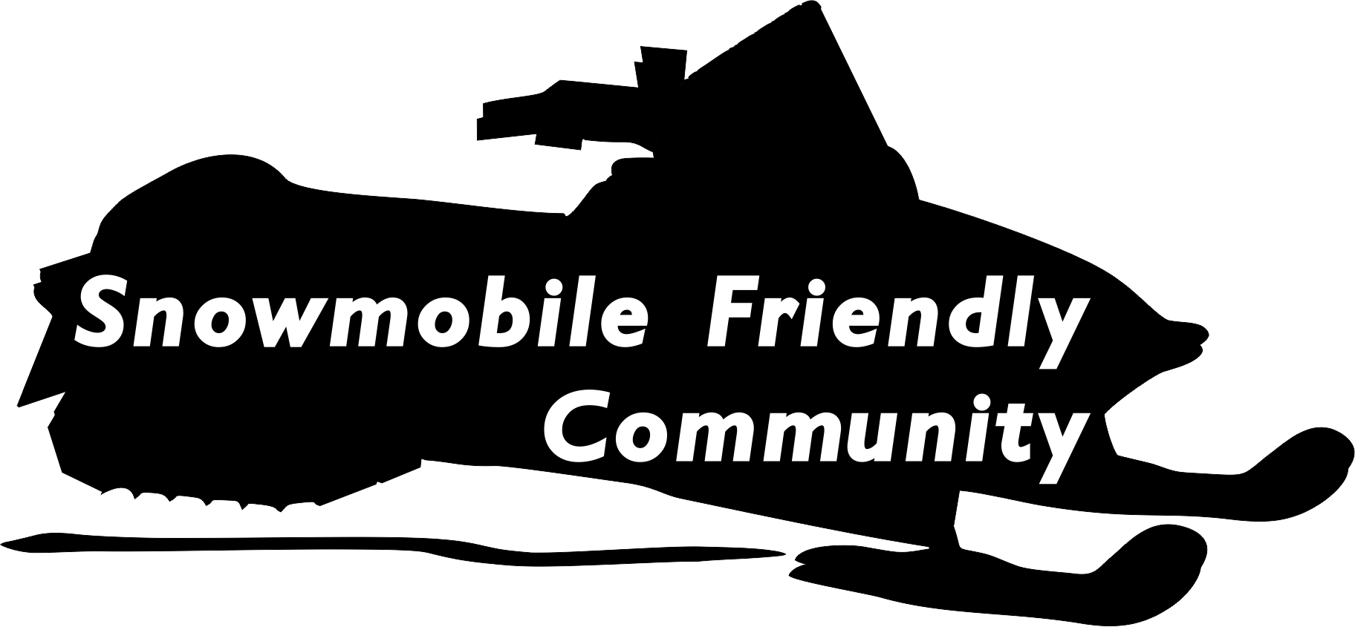
APPLICATION

- COMMUNITY CONTACT INFORMATION

Community Name: ________________________________________________________________

Contact Person’s Name and Title: ____________________________________________________

Mailing Address: __________________________________________________________________

Phone Number: __________________________ Fax Number: ___________________________

E-mail: ____________________________________________________________

- SPONSORING SNOWMOBILE CLUB CONTACT INFORMATION

Snowmobile Club Name: __________________________________________________

Contact Person’s Name and Title: ____________________________________________________

Mailing Address: __________________________________________________________________

Phone Number: __________________________ Fax Number: ___________________________

E-mail: ____________________________________________________________

- REQUESTED COMMUNITY INFORMATION

- Services Available By Snowmobile: Please check which, along with how many, of the following services can be accessed by snowmobile in your community:

- Fuel How many: ____
- Lodging How many: ____
- Food How many: ____
- Snowmobile repairs and parts How many: ____
- Other: ______________________ How many: ____

Indicate how this snowmobile access is provided (check all that apply):

- On a groomed trail
- On an ungroomed designated route
- Along a road shoulder
- On a plowed street or roadway
- Other: ______________________________________

Please provide the following information about your community, as applicable, with your completed application:

- Maps: Provide copies of maps, brochures, web links or other information showing area snowmobile trail systems and designated snowmobile routes through the community.
- Tourism Promotion: Provide examples of community snowmobile tourism promotion efforts or plans.
- Special Rules: Provide copies of any pertinent special rules (laws, policies, ordinances, regulations, etc.) which demonstrate how the community is ‘snowmobile-friendly.’ This could include rules that help:
- facilitate access by snowmobile to services within the community,
- facilitate access by snowmobile for residents from their homes to area trail systems, or
- preserve snow cover on snowmobile access routes.
- Community Support Statement: Provide a resolution, proclamation, or other statement of support for the community’s ‘snowmobile-friendly’ application from its governing body or official.
- Law Enforcement: Describe community efforts to provide equitable snowmobile enforcement in the area, snowmobile road sharing/road crossing safety education, or special training provided by or to local law enforcement specifically related to snowmobile use.
- Community Education Efforts: Describe any community efforts to educate businesses about how to cater to snowmobilers and promote snowmobile tourism.
- Promotion of Organized Snowmobiling: Membership of Chamber and/or tourism organization in local club and Minnesota United Snowmobilers Association.

- REQUESTED SNOWMOBILE CLUB INFORMATION

Please answer the following questions:
- Is your club affiliated in good standing with Minnesota United Snowmobilers Association by collecting MnUSA dues for all of your club members and submitting the dues to MnUSA? € Yes No
- Is your club a member of the local chamber of commerce and/or convention and visitors bureau?Yes No
- Does your club help provide snowmobile safety information or training in the community? € Yes No
- Does your club provide assistance to the community for emergency response needs?
€ Yes No
- Does your club support Snowmobile Friendly Community designation for this community?
€ Yes No

- SIGNATURES

__________________________________________ _______________________________________
(Community Signature) (Club Signature)

__________________________________________ _______________________________________ (Name and Title – typed or printed) (Name and Title – typed or printed)

__________________________________________ _______________________________________
(Date) (Date)

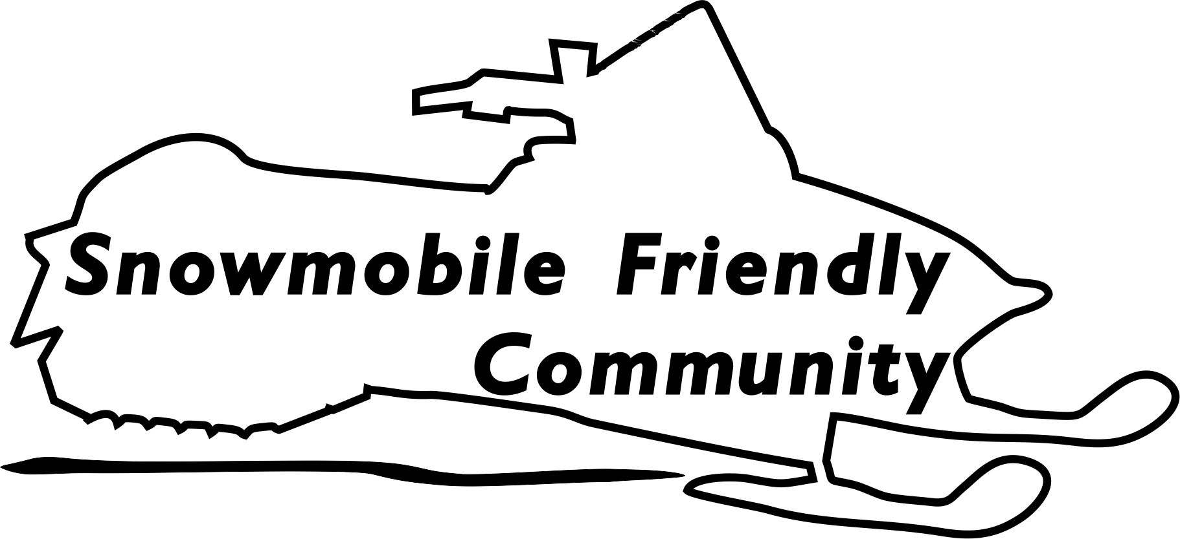
SAMPLE
COMMUNITY CERTIFICATION
CRITERIA SCORESHEET
(To be Completed by MnUSA)

SCORING: 1 point for every Yes; 0-3 = community needs improvement to qualify for designation; 4-6 = good start, community can apply for Snowmobile Friendly designation with approval subject to association’s discretion; 7-10 = community caters to snowmobilers and should likely qualify for Snowmobile Friendly designation

Local Snowmobile Club Criteria (club must be 100% members of MnUSA)
€ Yes No Club Active in Community: Is the club a member of the area’s chamber of commerce, convention and visitors bureau, or/and assist with emergency response needs?

Community Related Criteria
€ Yes No Trail Connection: is the community directly connected to a groomed snowmobile trail?
€ Yes No Tourism Promotion: does the community help provide area snowmobile trail maps, provide other information to assist snowmobilers with trip planning, actively promote snowmobile tourism, or host special snowmobile events?
€ Yes No Snow Removal Doesn’t Create Hazards: does the community manage local snow removal efforts to help prevent creating safety hazards caused by snow removal operations unnecessarily depositing snow onto groomed snowmobile trails and connecting routes?
€ Yes No Aggressive Snow Removal Doesn’t Hurt Access: does the community manage local snow removal efforts to help prevent unnecessarily removing all snow cover from designated connecting routes (streets and road shoulders) needed for snowmobile access to key fuel, lodging and food services?

Local Community Business Related Criteria
€ Yes No Fuel Available: does at least one business have fuel available and accessible by snowmobile?
€ Yes No Lodging Available: does at least one business have lodging available and accessible by snowmobile?
€ Yes No Other Services Available: does at least one business have food or repair parts available and accessible by snowmobile?

Local Community Law Enforcement Related Criteria
€ Yes No Business Access: does the community have an ordinances or other policy that allows snowmobilers to access businesses by groomed trails and/or other designated over-snow routes including designated plowed streets or roadways?
€ Yes No Residential Access: does the community have an ordinance or other policy that allows snowmobilers to travel from their homes by following designated plowed streets or roadways to the outskirts of the community or to designated snowmobile trail routes?

TOTAL SCORE: _________

MEMORANDUM OF UNDERSTANDING

This MEMORANDUM OF UNDERSTANDING (MOU) ishereby made and entered into by and between the community of _____________________________________ (hereinafter “community”), the _______________________________________________ Snowmobile Club (hereinafter “club”), and the Minnesota United Snowmobilers Association (hereinafter “association”).

PURPOSE: The purpose of this MOU is for the parties to cooperatively work together to advance and promote safe snowmobile access routes to services located within the community while endorsing the community as a ‘Snowmobile Friendly Community’ to benefit its tourism development efforts.

- STATEMENT OF MUTUAL BENEFIT AND INTERESTS:
- The community hosts a variety of businesses which offer fuel, food, lodging, and/or repair services required by snowmobilers.
- The club and association represent the organized snowmobiling public and work to foster safe and dependable access routes for snowmobilers.
- Snowmobiling provides important winter tourism that generates substantial economic impacts through visitor spending and tax revenues.

In consideration of the above premises, the parties agree as follows:

- THE COMMUNITY AGREES TO:
- Provide safe and reliable access routes by snowmobile to designated community businesses which can provide fuel, lodging, food, repairs and supplies for snowmobilers
- Promote itself as ‘snowmobile friendly’ to aid snowmobilers with their trip planning
- Provide trail maps or other informational material to aid snowmobiler trip planning
- Consider ordinances or policies that allow residents to travel by snowmobile from their homes on designated plowed streets or roadways to either the outskirts of the community or to designated snowmobile trail routes
- Consider ordinances or policies that allow snowmobiles to access businesses by either groomed trails or other properly designated over-snow routes including plowed streets or roadways
- Manage local snow removal efforts, to the extent feasible, to help prevent creating safety hazards caused by snow removal operations unnecessarily depositing snow onto groomed snowmobile trails and connecting routes
- Manage local snow removal efforts, to the extent feasible, to help prevent unnecessarily removing all snow cover from designated connecting routes (streets and road shoulders) needed for snowmobile access to key fuel, lodging and food services
- Promote good road sharing etiquette and road crossing regulation for snowmobile-automobile interaction
- Have designated representatives meet with the club at least annually to help coordinate snowmobile-friendly policies and to address snowmobile management issues

- THE CLUB AGREES TO:
- Support the community in its efforts to be a Snowmobile Friendly Community
- Promote the community as a Snowmobile Friendly Community on its website as well as in its publications or other appropriate snowmobiling promotional materials
- Support the community by helping to provide snowmobile safety information and training
- Support the community by assisting with emergency response needs

- THE ASSOCIATION AGREES TO:
- Formally designate the community as a Snowmobile Friendly Community
- Promote the community as a Snowmobile Friendly Community on its website as well as in its publications or other appropriate materials
- Provide the Snowmobile Friendly Community program logo to the community for its snowmobile tourism promotion efforts
- Make Snowmobile Friendly Community signs available for posting along community roadways or trails

- IT IS MUTUALLY UNDERSTOOD AND AGREED BY AND BETWEEN THE PARTIES THAT:
- PARTICIPATION IN SIMILAR ACTIVITIES: This MOU in no way restricts any party from participating in similar activities with other entities.
- NONBINDING AGREEMENT: This MOU creates no right, benefit, or trust responsibility, substantive or procedural, enforceable by law or equity. The parties shall manage their respective resources and activities in a separate, coordinated and mutually beneficial manner to meet the purpose(s) of this MOU. Nothing in this MOU authorizes any of the parties to obligate or transfer anything of value.
- EXPIRATION DATE: This MOU expires five (5) years from the date of approval by the parties, unless extended by an executed modification signed and dated by all parties.
- MODIFICATIONS: This MOU may be modified by mutual consent at any time by written request of one of the parties at least 30 days prior to implementation of the requested change.
- TERMINATION: Any of the parties, in writing, may terminate this MOU in whole, or in part, at any time before the date of expiration in writing to the parties at the addresses below.
- AUTHORIZED REPRESENTATIVES: By signature below, each party certifies that the individuals listed are authorized to act in their respective areas for matters related to this MOU. In witness whereof, the parties hereto have executed this MOU as of the last date written below.

- SIGNATURES:

FOR THE LOCAL SNOWMOBILE CLUB:

Name: ____ Title:

Address: _______________________________________________________ Phone: _____________

Signature: _____ Date: _____________

FOR THE COMMUNITY:

Name: ____ Title:

Address: _______________________________________________________ Phone: _____________

Signature: _____ Date:

FOR THE STATE SNOWMOBILE ASSOCIATION:

Name: ____ Title:

Address: _______________________________________________________ Phone: _____________

Signature: _____

Date:

